**A1: Output**

1. **Check whether your file handling is correctly done**

: find the size of employees and display all employees

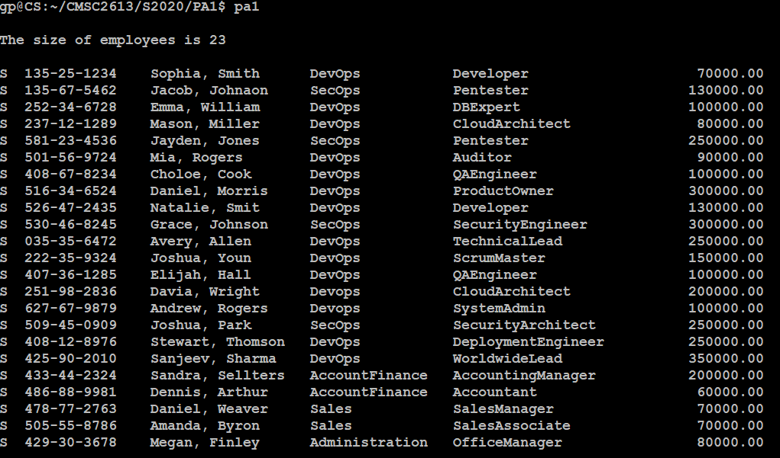

1. **Search and Exit test**

* **Find an employee by SSN**
* **Display all the employee ijn SecOps team**
* **Display only developers in DevOps team**
* **Exit the program**

Search by SSN/ SecOps

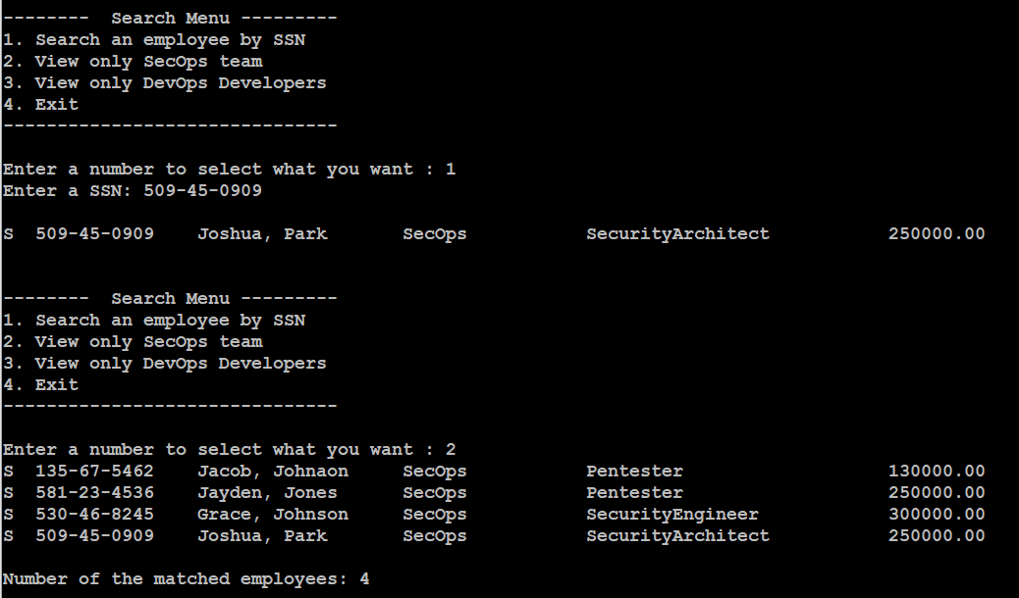

**DevOps and Developers**

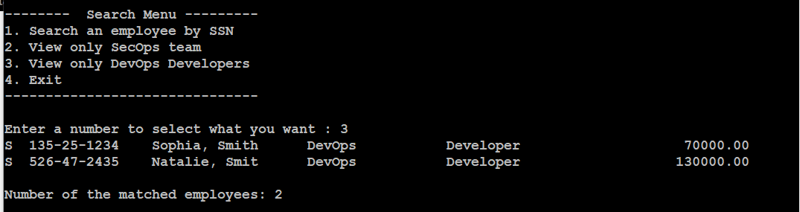

**Exit**

